

**A Project Report On**

**“Online Shopping System”**

Supervised By

Mr. Mohammed Mahmudur Rahman

Assistant Professor

Department Of Computer Science & Engineering, IIUC

Prepared By

Dipa Dey

ID: C201226

Semester :3rd

Section: 3AF

Department Of Computer Science & Engineering, IIUC

i

**ABSTRACT**

Now a days the life style of the people is different. Online shopping is the easy solution for busy life in today’s world. People feel uncomfortable and time consuming for going crowded markets. So, Online Shopping is a boon as it saves lot of time. Online shopping is a process whereby consumers directly buy goods, services etc. from a seller over the Internet. Online stores are usually available 24 hours a day and many consumers have internet access both at work and at home. So it is very convenient for them to shop Online. One of the most enticing factors about online shopping, particularly during holiday season is, it alleviates the need to wait in long lines or search from a store for a particular item. O**nline shopping is also useful for the customer that they can purchase in there home are somewhere else from there location.  They can see all the products and different types of products. They can order the product they want, it will be delivered within a week or days. the payment for the product will be done by online payment or else cast on delivery. So the customer can pay for there convenience. If any problem in the product, the customer can return the product through online. After a few days, they will come and pick the product and customer can also buy another product.**

ii

**TABLE OF CONTENTS**

* ABSTRACT ii
* TABLE OF ABBREVIATIONS iii – iv

**TABLE OF ABBREVIATIONS**

CHAPTER - 1 : INTRODUCTION ..................................................................... **01 - 04**

* 1. Objectives ............................................................................. 02
  2. Scope ....................................................................................... 02
  3. Problems Of Existing System ............................................. 03-04

CHAPTER - 2 : BACKGROUND ...................................................................... **05 - 08**

2.1 Proposed System ................................................................ 06

2.2 Why is our system better? ................................................. 07 - 08

CHAPTER - 3 : METHODOLOGY ...................................................................... **09 - 17**

3.1 Software/Application Development Life Cycle .......... 10 - 11

3.2 Agile Model ............................................................................ 12

3.3 Requirement collection and analysis ............................ 13

3.4 Feasibility study .................................................................... 14

3.5 Use Case Diagram ................................................................ 15 - 17

iii

CHAPTER - 4 : SOFTWARE DESIGN & IMPLEMENTATION ...................... **18 - 32**

4.1 Data Flow Diagram (DFD) ................................................ 19 - 20

4.2 Entity Relationship Diagram .............................................. 21 - 22

4.3 Technologies used .................................................................. 23

4.4 Tools Used ............................................................................... 23

4.5 Interface Design ....................................................................24 - 32

CHAPTER - 5 : CONCLUTION ........................................................................... **33 - 34**

5.1 Future Plan Of Project ........................................................ 34

REFERENCES .......................................................................................................... **34**

iv

**CHAPTER - 1**

INTRODUCTION

It may seem like nearly everything’s gone digital these days. Television, books, and even shopping have been booming online. Online shopping is a form of electronic e-commerce where customers can buy their essential goods without any disturbance. Online shopping through app has become very popular these days because people find it convenient and easy to shop from their home or office. People can save their time and energy by purchasing products online with some discounts. The offers on the internet can be easily compared, and the buyer can buy the product according to their favorable conditions like price, quality and other discounts for their individual needs. The next generation of mobile phone “SMART Phones”, has opened the new paths of using specially designed apps. We have most of the companies making use of this trend of getting their company products available on their website for sale, to be accessed via the app. They are also coming out with some great offers to attract customers to download and use their apps more rather than accessing their website.

01|Page

1.1 Objectives

* Online shopping makes consumers satisfy because they can buy goods with lower prices without spending extra energy to shop many shops.
* Online shopping provides an easy way to shop and it reduces the total time consumers’ spent on purchasing goods.
* Consumers are accessing the information easily with less time spent.
* Customers be able to easily save money and compare prices from website to website.

1.2 Scope

Purchasing and selling products and services over the internet without the need of going physically to the market is what online shopping all about. Online shopping is just like a retail store shopping that we do by going to the market, but it is done through the internet. Online shopping has made shopping painless and added more fun. Online stores offer product description, pictures, price and much more. Few examples of these are Amazon.com, ebay.com, framt.com etc. Online shopping makes use of digital technology for managing the flow of information, products and payment between consumer, site owners and suppliers. Online shopping can be either B2B (business to business) or B2C (business to consumer)

Shopping cart is one of the important facility provided in online shopping, this lets customer to browse different goods and once they select an item to purchase they can place the item in shopping cart, and continue browsing till the final selection. Customers can even remove the items that were selected earlier before they place the final order. It reminds us of shopping basket that we carry in departmental store.

02|Page

1.3 Problems Of Existing System

### **Poor Searching Engine**

Customers choose shopping online because it is also to avoid waiting or queuing when shopping in store. So there are no reason for them to keep waiting when shopping online just because the website loads slowly and has poor searching engine. Most consumers search for several minutes in a category before selecting one or more products for purchase. If navigation is not smooth, they will end up getting tired and leaving the site, leaving behind an abandoned shopping cart. This is one of the problems faced by ecommerce consumers when shopping online. (tram, 2021)

1. **Logistics-related problems:**

There are lot of online shopping problems faced nowadays. Another problem faced in online shopping is issues with delivery and logistics. Products are often lost or damaged while in transit, and order tracking systems are unable to accurately locate the product. People choose the same-day. one-day or two-day delivery, paying extra money to get their product delivered.

However, these products often do not get delivered within the stipulated time and consumers have to wait for days before they finally receive their product. Similar challenges are faced by consumers when it comes to returning the product. (MyAdvo, 2018)

03|Page

### **Poor customer service**

This is the main problem customers face when shopping online. When they want to ask more information about the product to the seller, they get too slow reply. This situation is similar for customers who have purchased and are having questions or problems with the product.

### **Lack of payment options**

This is another common problem when shopping online. A lot of times, consumers do not know how to make the payment if the debit cards they use are not available as an option. Customers are also often stuck with the payment options when Cash on Delivery is not available.

With online frauds picking up steam, most customers prefer paying cash on delivery as they are skeptical about sharing their card details. This is a common complaint by many customers these days. They do not have many payment methods that they can use and trust.

04|Page

CHAPTER - 2

BACKGROUND

Online shopping is the future of shopping which is fast evolving in the present. But online shopping didn’t develop overnight. Certain breakthroughs led to its development; these are the historical frameworks that make online shopping the easiest form of shopping.

* Electronic shopping was invented by an English inventor called **Michael Aldrich**, In **1979.**
* The invention of the first ever web browser, i.e. the **World Wide Web** in **1990** is the second major proponent of online shopping.
* In **1994**, **Netscape** developed an encryption-based internet security protocol called **SSL** – or Secure Sockets Layer.
* **1995** welcomed the biggest transformation of online shopping. The first online marketplaces were established. First came **Amazon.com,** launched by **Jeff Bezos,** the richest man in the world as of 2019 with an estimated net worth of $115 billion.
* At the turn of the 21st century in **2000**, Google launched **Adwords** , an advertising service that allows sellers to place adverts in Google search results related to viewers’ search preference.
* In **2004**, **Shopify**, a prominent online storefront service made it possible for low-capital sellers to set up online stores.
* In **2006**, **PayPal** launched a new way for people to exchange money and buy things they want online directly from their cell phones.
* As of 2020, it’s clear to see that the entire internet is now a virtual shopping mall. With people choosing to carry out trades on Instagram, Whatsapp and Facebook, it’s safe to say that we are in the online shopping era. **(donszem, 2020)**

05|Page

* 1. Proposed System

In the proposed system the customer will select category of product and after that the system will show him/her all product under this category. Customer will select the product and also select the wanted quantity and add this product to the cart shopping. The system automatically will show all cart products with their price and quantity and the total for each product and also the net total for all orders. The proposed system consists of the

* Order Page
* Register Page
* Product Page
* Admin pages
* Category Pages
* ASP.NET:

Prior to the advent of ASP.NET, three main technologies and platforms were available to develop Web applications: ASP, Java Server Pages (JSP), and the opensource Web platform commonly referred to as LAMP (Linux plus Apache plus MySQL plus either Perl, Python, or PHP as the Programming language).

06|Page

* 1. Why is our system better?
* **SAVE OUR TIME**

Online Shopping is much better than going into stalls and shops to buy goods and ask for services to be rendered because it saves a lot of time. One can easily browse through different online shops and e-commerce stores to select whatever they want within the shortest possible time.

* **LESS STRESSFUL**

Shopping online significantly saves one of a lot of stress. When consumers are online, there is no fear of bumping into a crowd or having to join a long queue before they purchase whatever they want to buy. Some locations of some supermarkets are also in top cities where there are many people and each time someone goes out to get things to buy, the road can be very crowded and sometimes one can even be robbed if one is not careful. Via the online shopping there is no option of robbery.

07|Page

* **Save Transportation Expenses**

Online shopping is not associated with any transportation expenses. Consumers simply order what they want from home. All the products they order would be delivered to their doorstep as well. Therefore, they will get the opportunity to [avoid transportation expenses](http://www.telegraph.co.uk/women/womens-life/9812220/How-to-save-money-on-transport-costs-and-supermarket-shopping.html).

# **Products are Cheaper**

Products available in online stores generally tend to be cheaper when compared to the physical stores. On the other hand, consumers get some exciting opportunities to save money as well. For example, they [benefited from the Black Friday Deals](https://black-friday.discount/) and save a considerable amount of money on what they purchase. They will never be able to get such amazing discounts from physical stores.

08|Page

CHAPTER - 3

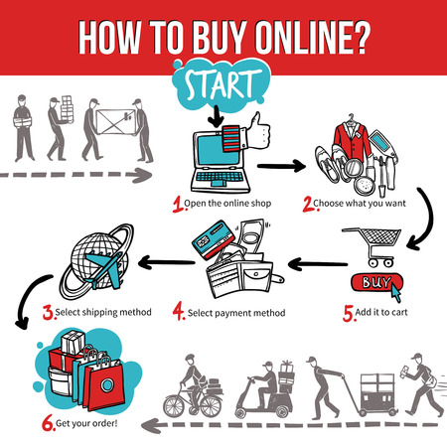 METHODOLOGY

**Online shopping: how to buy online**

* Step 1: Search for a product using Google shopping.
* Step 2: Find an item that consumers want using Google shopping.
* Step 3: Select shipping method via Google shopping.
* Step 4: Select payment method according to the Google shopping.
* Step 5: Adding the product to basket.
* Step 6: Get his/her product or Continue shopping.

09|Page

3.1 Software/Application Development Life Cycle

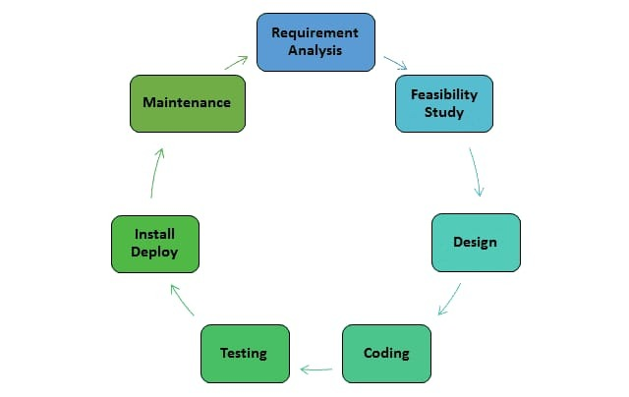

Software development life cycle (**SDLC**) is a series of [phases](http://melsatar.blog/2017/06/13/what-do-you-need-to-know-about-the-eight-software-development-phases/) that provide a common understanding of the software building process.

10|Page

SDLC Phases

* Requirement gathering and analysis
* Feasibility study
* Design
* Implementation or coding
* Testing
* Deployment
* Maintenance

## **Types of Software development life cycles (SDLC)**

* [Waterfall Model](http://melsatar.blog/2018/02/16/the-waterfall-model-a-different-perspective/)
* [V-Shaped Model](https://melsatar.blog/2018/08/27/the-validation-and-verification-model-the-v-model/)
* [Evolutionary Prototyping](http://en.wikipedia.org/wiki/Software_prototyping) Model
* [Spiral](http://en.wikipedia.org/wiki/Spiral_model) Model
* [Iterative and Incremental](https://melsatar.blog/2019/01/05/let-waterfall-model-be-extinct/) Method
* Big Bang model
* Agile model

**SOFTWARE PROCESS MODEL:**

Developing the Online shopping System, i have followed the Agile model.

11|Page

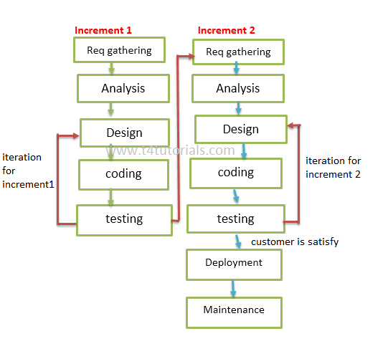3.2 Agile model

The agile model is relatively well-known, particularly in the software development industry.

The agile methodology prioritizes fast and ongoing release cycles, utilizing small but incremental changes between releases. This results in more iterations and many more tests compared to other models.

Theoretically, this model helps teams to address small issues as they arise rather than missing them until later, more complex stages of a project.

12|Page

3.3 Requirement collection and analysis

**NON-FUNCTIONAL REQUIREMENTS**

1. **EFFICIENCY REQUIREMENT:** When an online shopping cart android application implemented customer can purchase product in an efficient manner.
2. **RELIABILITY REQUIREMENT:** The system should provide a reliable environment to both customers and owner. All orders should be reaching at the admin without any errors.
3. **USABILITY REQUIREMENT:** The android application is designed for user friendly environment and ease of use.

**FUNCTIONAL REQUIREMENTS**

* Username and password will be provided after user registration is confirmed.
* Password should be hidden from others while typing it in the field.
* System must be able to verify and validate information.
* The system must encrypt the password of the customer to provide security.
* System must ensure that, only a registered customer can purchase items.
* The system must identify the login of the admin.
* Admin account should be secured so that only owner of the shop can access that account.

13|Page

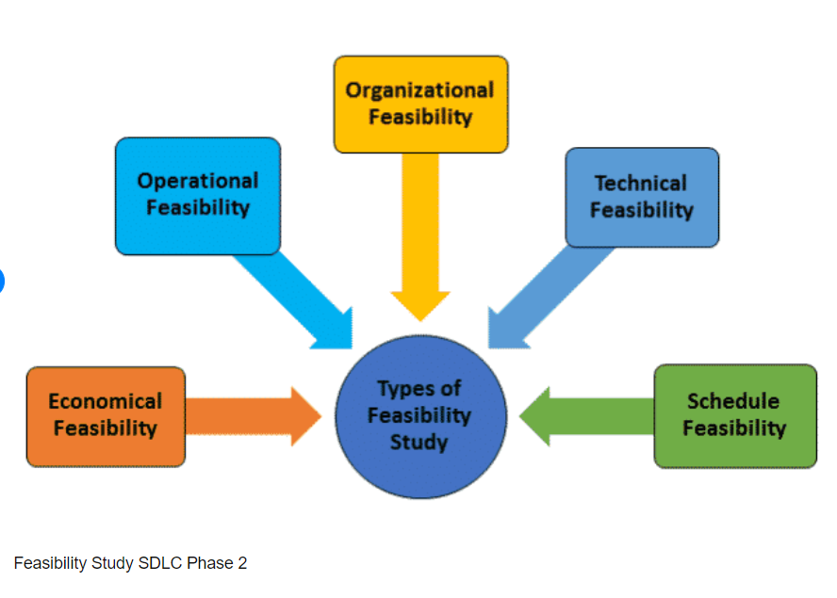3.4 Feasibility study

* As the name suggests, feasibility study is a study to reveal whether a project is feasible or not.
* It is conducted in order to find answers to the following questions:
* Do we have required resources and technologies to build the project?
* Do we receive profit from the project?
* It tells us whether a project is worth the investment.
* After the feasibility study, the project may be accepted, accepted with modifications or rejected.

14|Page

3.5 Use Case Diagram

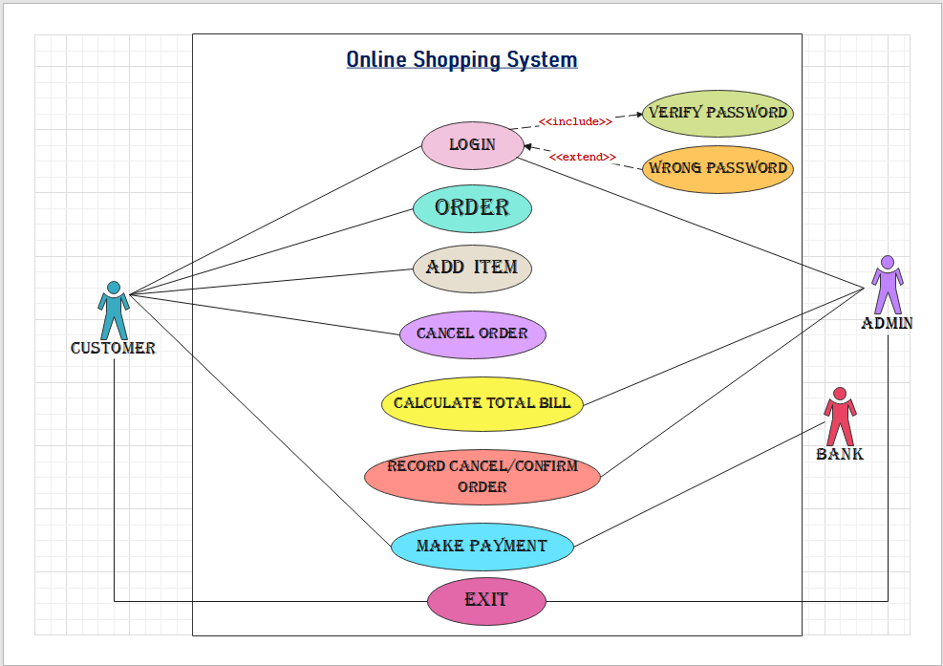

**Use Case Diagram Of Online Shopping System System**

15|Page

* A use case diagram is a graphical depiction of a user's possible interactions with a system. A use case diagram shows various use cases and different types of users the system has and will often be accompanied by other types of diagrams as well. The use cases are represented by either circles or ellipses. The actors are often shown as stick figures.

**Actor**

**Actor** in a use case diagram is any entity that performs a role in one given system. In this diagram, the actors are:

* **Customer**
* **Admin**
* **Bank**

**Use Case**

**A use case represents a function or an action within the system. The use cases used in this diagram are:**

* **login**
* **Order**
* **Add item**
* **Cancel order**
* **Calculate total bill**
* **Record cancel/confirm order**
* **Make payment**
* **Exit**

16|Page

**Extend**

Sometimes the use case connected by extending can supplement the base use case. The thing to remember is that the base use case should be able to perform a function on its own even if the extending use case is not called.

**System**

The system is used to **define the scope of the use case** and drawn as a rectangle. This is an optional element but useful when you’re visualizing large systems. Now it’s time to identify the whole system of this diagram. A good way to do this is to identify what the actors need from the system.

The online shopping system, which is shown above, is a system where at first a customer and admin must login to enter this system. After logging the customer will be able to order any product. Customer can add new product if desired, again can be canceled product if they want. After that admin calculate the total bill of these products and create a record of the product that the customer want to order or cancel. Then the customer will complete the payment via credit card through bank. So all of these can be considered as use cases. Top level use cases should always provide a complete function required by an actor.

17|Page

CHAPTER - 4

SOFTWARE DESIGN & IMPLEMENTATION

Software design is the solution for the creation of a new system. This phase focuses on the detailed implementation of the feasible system. It emphasis on translating design. Specifications to performance specification. Software design has two phases of development -

1. Logical design
2. Physical design

18|Page

* 1. Data Flow Diagram (DFD)

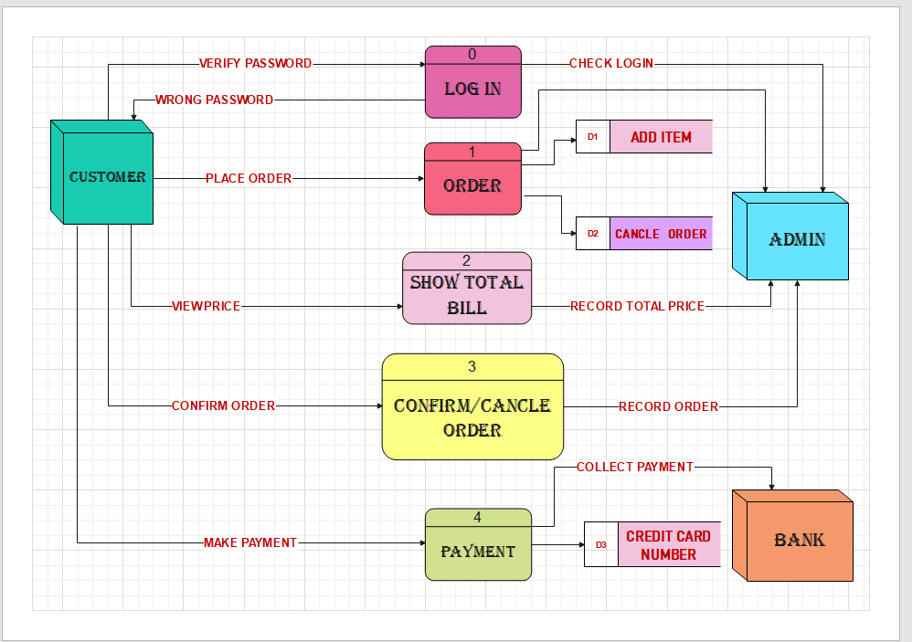

**Data Flow Diagram Of Online Shopping System**

19|Page

**Data Flow Diagram**: A data flow diagram shows the way information flows through a process or system. It includes data inputs and outputs, data stores, and the various subprocesses the data moves through. DFDs are built using standardized symbols and notation to describe various entities and their relationships.

**Process**

A **process** transforms incoming data flow into outgoing data flow. In this diagram, the process are:

* **login**
* **Order**
* **Show total bill**
* **Cancel/confirm order**
* **Payment**

**External entity**

**External entities** are objects outside the system, with which the system communicates. External entities are sources and destinations of the system's inputs and outputs. In this diagram, the External entities are:

* **Customer**
* **Admin**
* **Bank**

**Data Flow:** A stright line with arrow shows the flow of data into or out of a process or data store.

**Data Store:** A set of parallel lines shows a place for the collection of data items. A data store indicates that the data is stored which can be used at a later stage or by the other processes in a different order.

20|Page

* 1. Entity Relationship Diagram

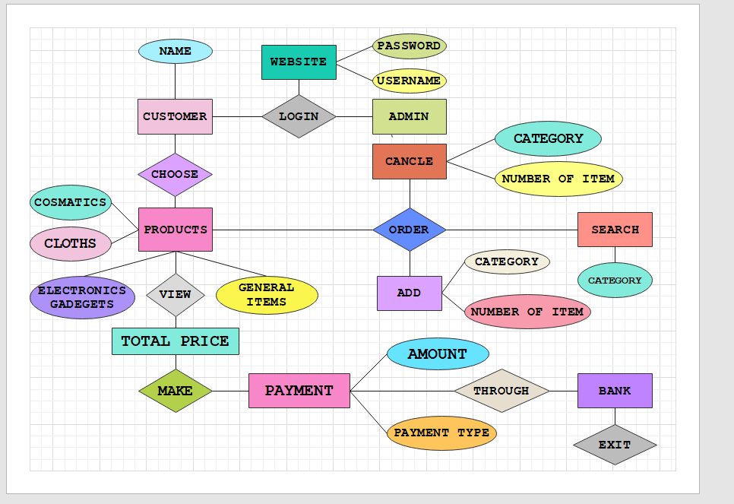

**Entity Relationship Diagram Of Online Shopping System**

21|Page

**Entity Relationship Diagram:** An entity relationship diagram (ERD) shows the relationships of entity sets stored in a database. An entity in this context is an object, a component of data. An entity set is a collection of similar entities. These entities can have attributes that define its properties. By defining the entities, their attributes, and showing the relationships between them, an ER diagram illustrates the logical structure of databases. ER diagrams are used to sketch out the design of a database.

As shown in the above diagram, an ER diagram has three main components:  
**1.** Entity  
**2.** Attribute  
**3.** Relationship

### **Entity:** An entity is an object or component of data. An entity is represented as rectangle in an ER diagram. In this diagram, the entities are: Customer, admin, products, payment, bank etc.

### **Attribute:** An attribute describes the property of an entity. An attribute is represented as Oval in an ER diagram. In this diagram, the attributes are: Username, password, category, amount, number of item etc.

### **Relationship:** A relationship is represented by diamond shape in ER diagram, it shows the relationship among entities. In this diagram, the relationships are: Login, choose, view, order, exit etc.

22|Page

* 1. Technologies used
* C++

* 1. Tools Used
* Code Blocks
* Wondershare EdrawMax
* Microsoft Word

23|Page

4.5 Interface Design

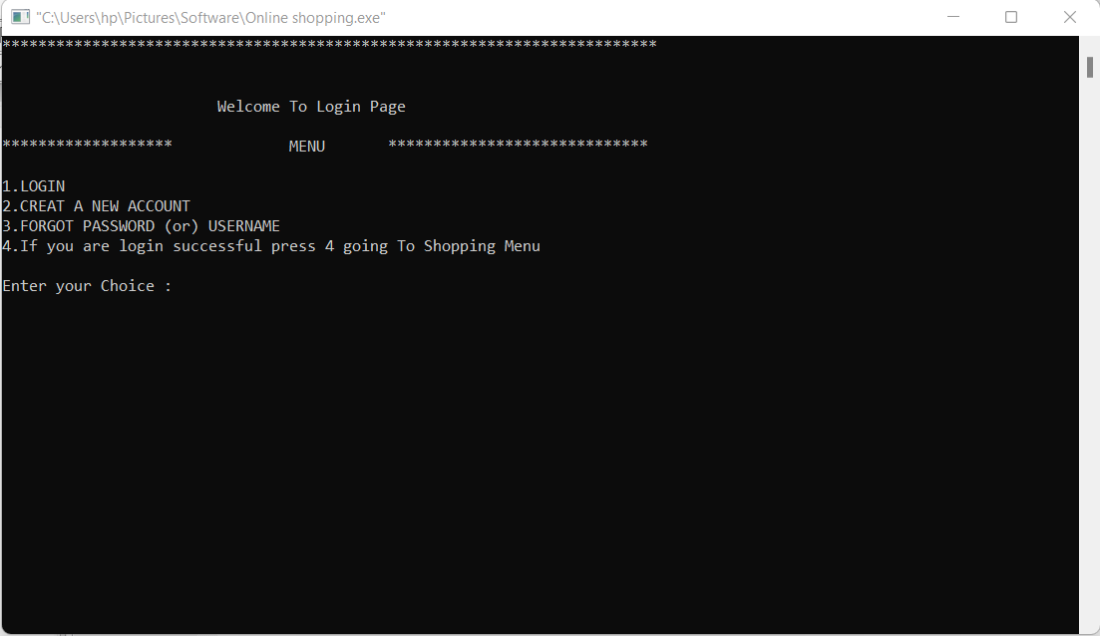

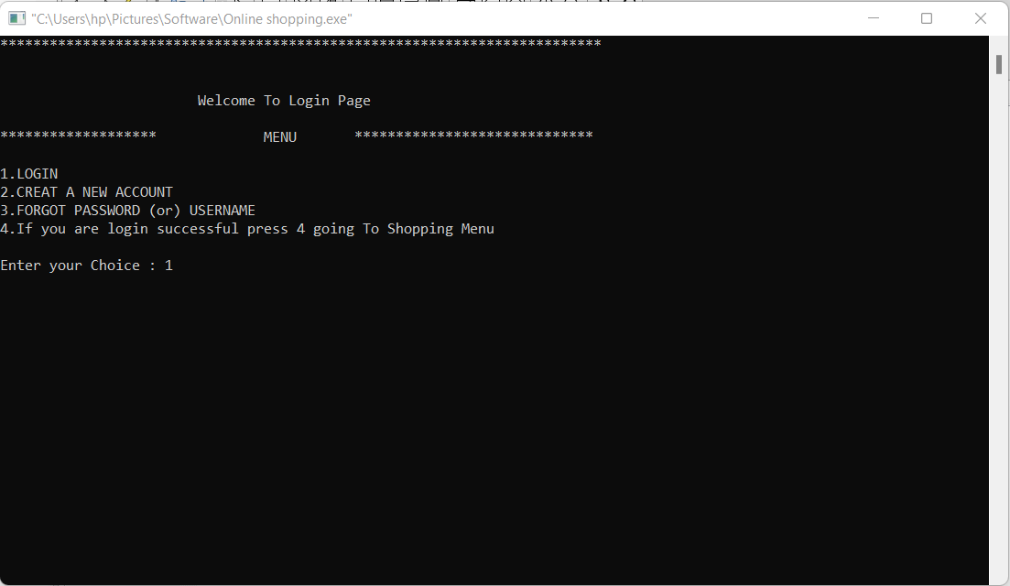

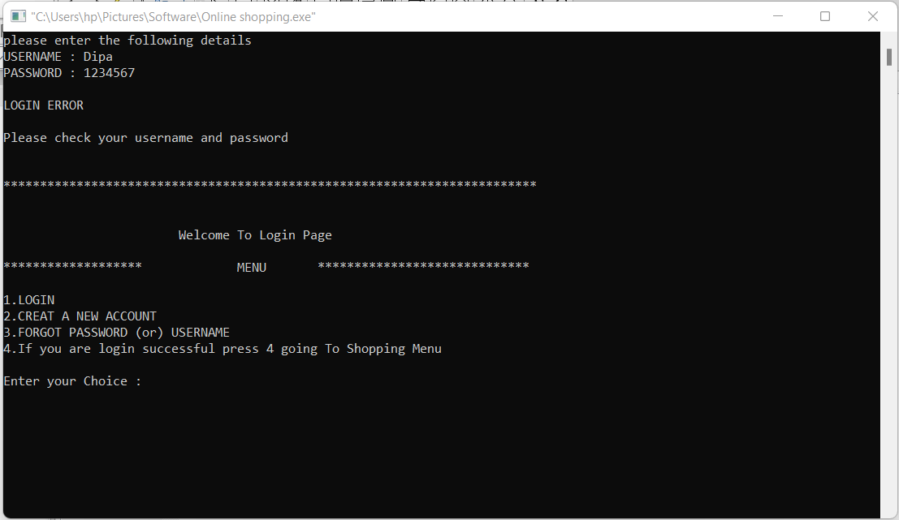

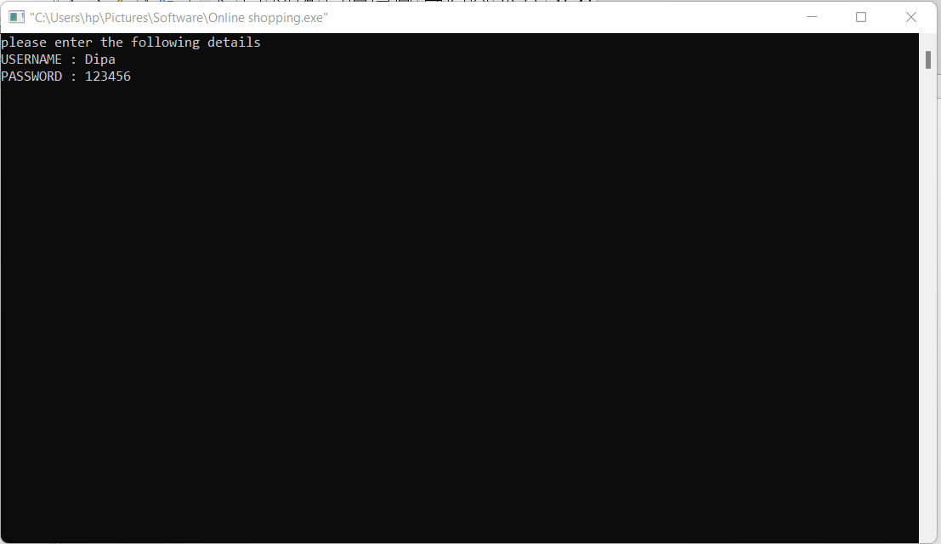

24|Page

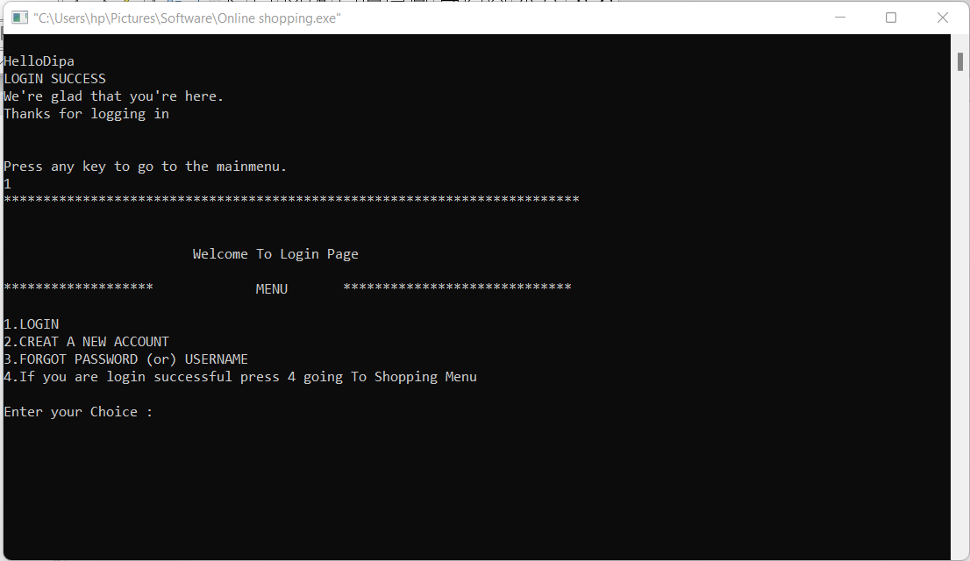

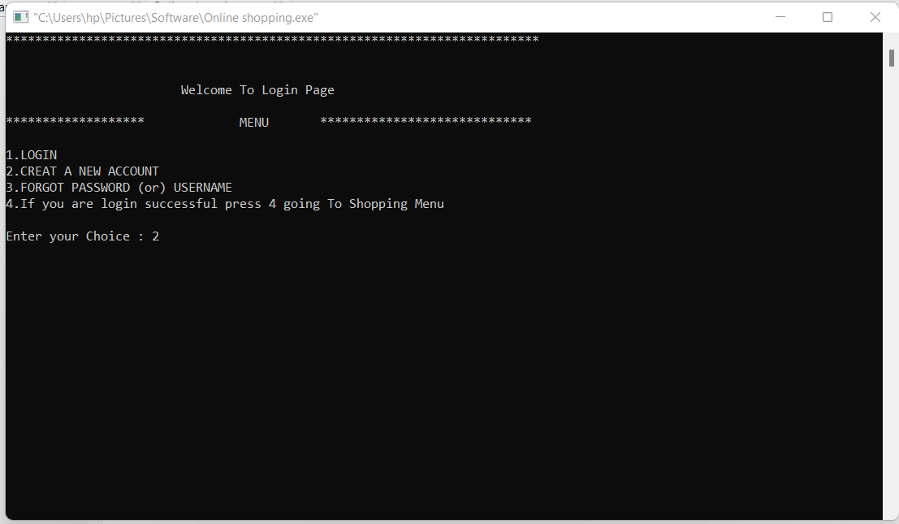

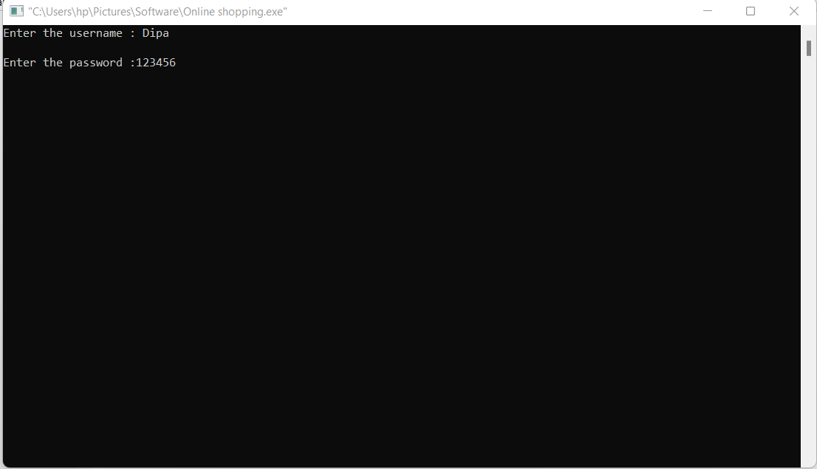

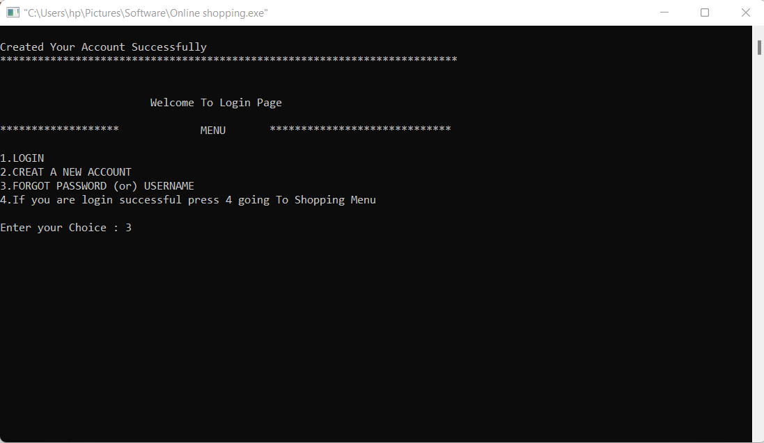

25|Page

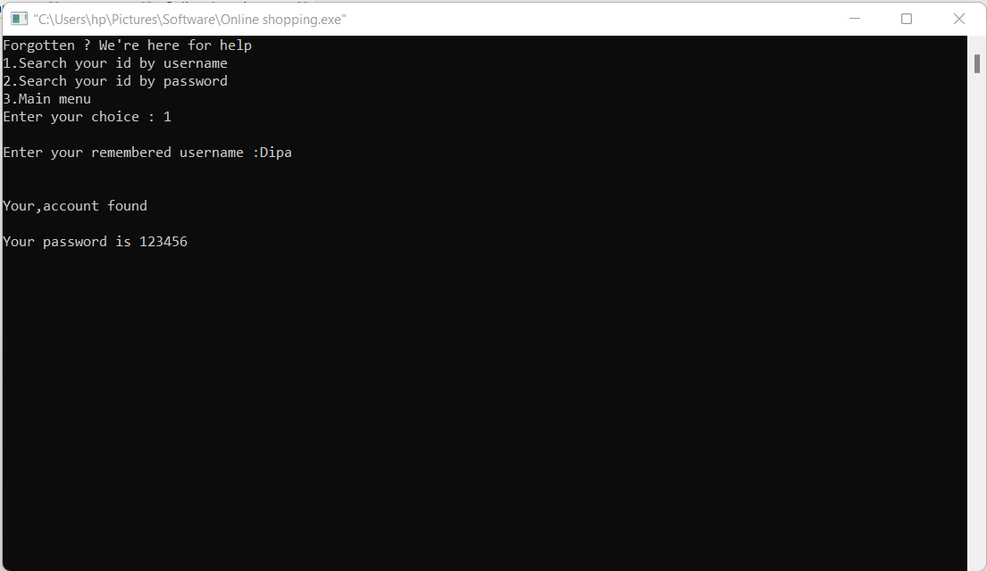

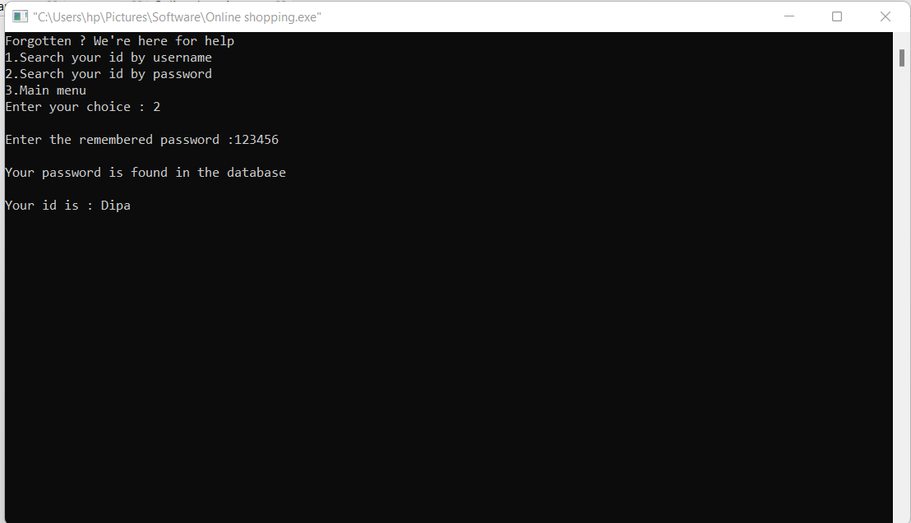

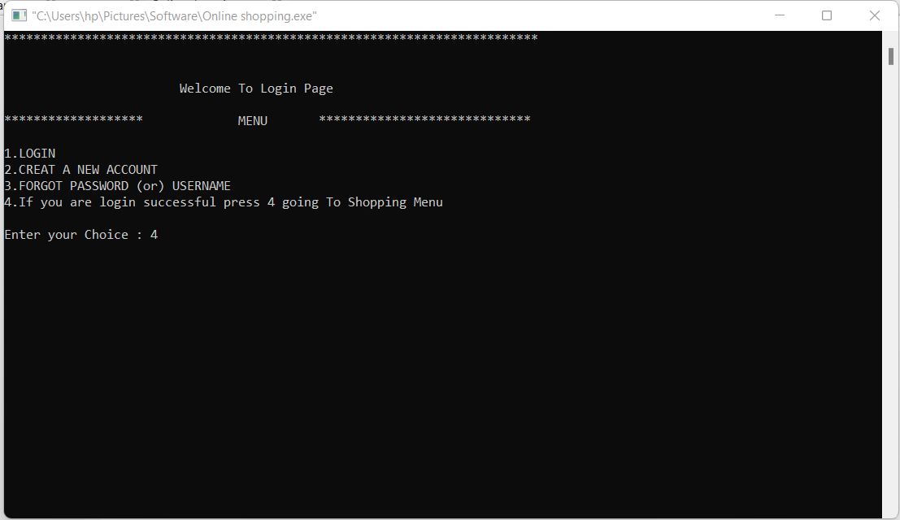

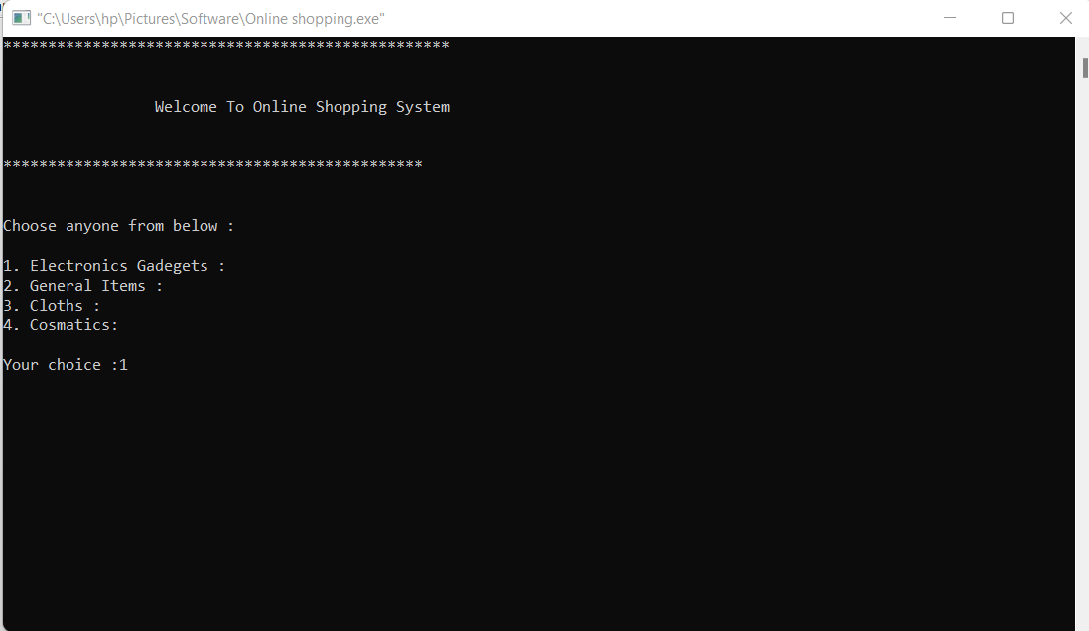

26|Page

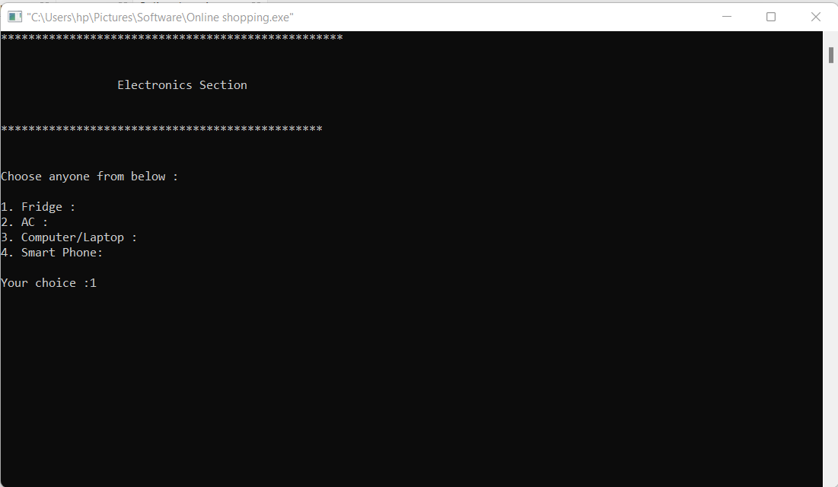

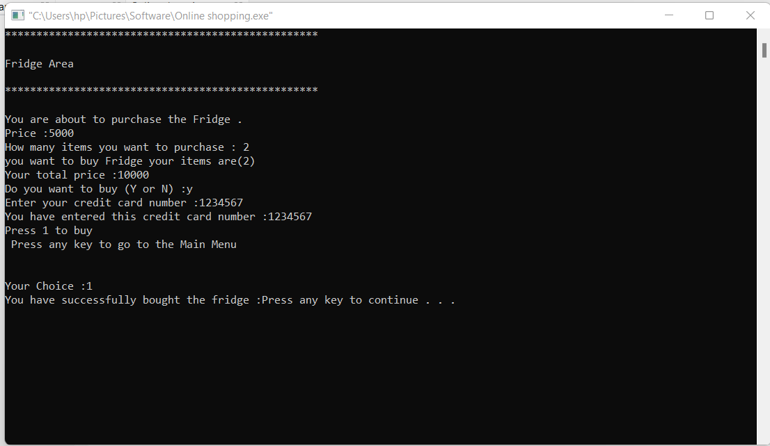

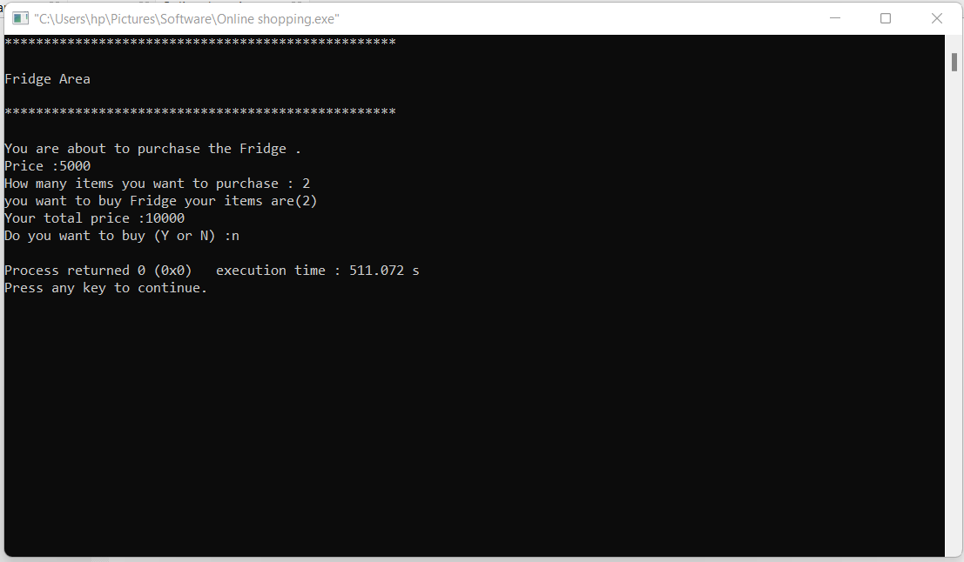

27|Page

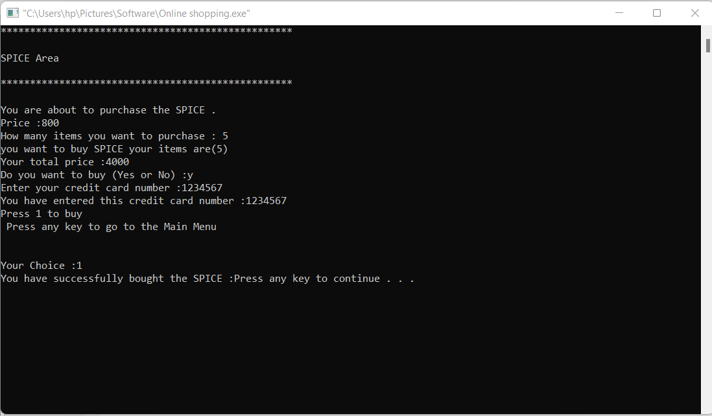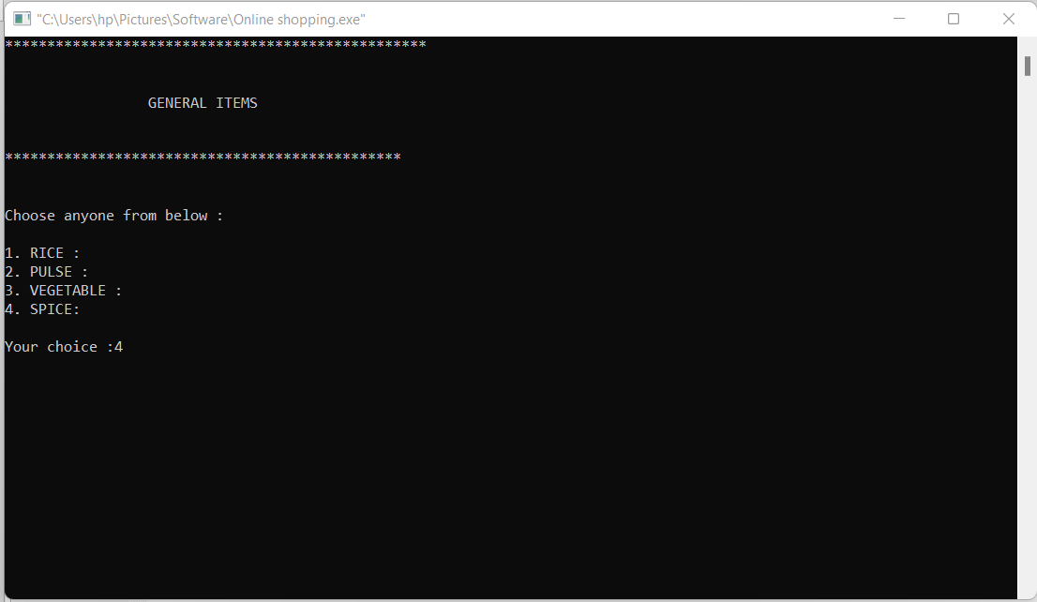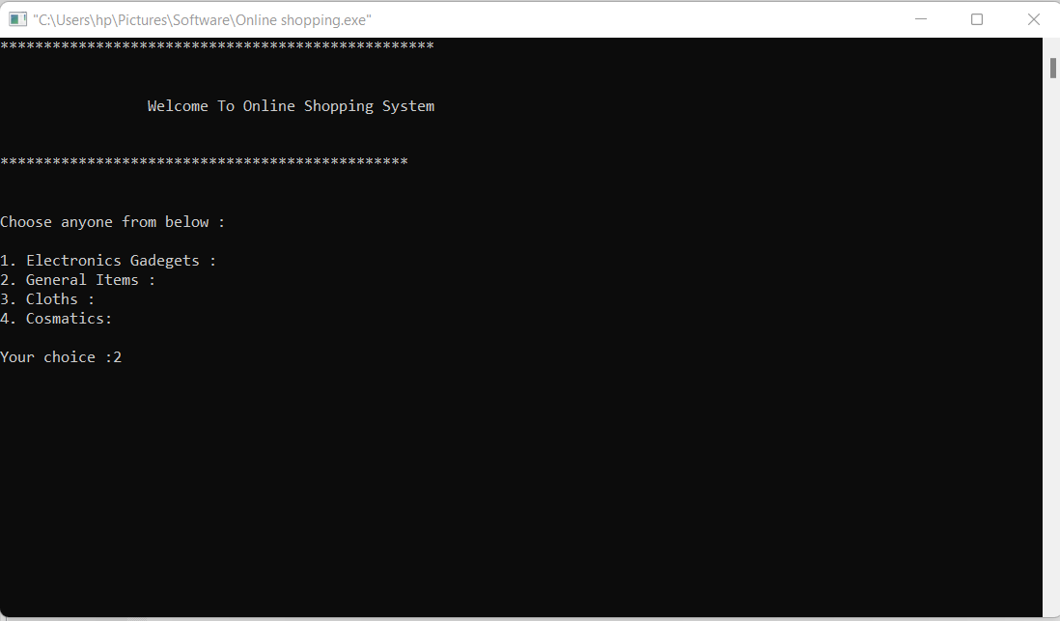

28|Page

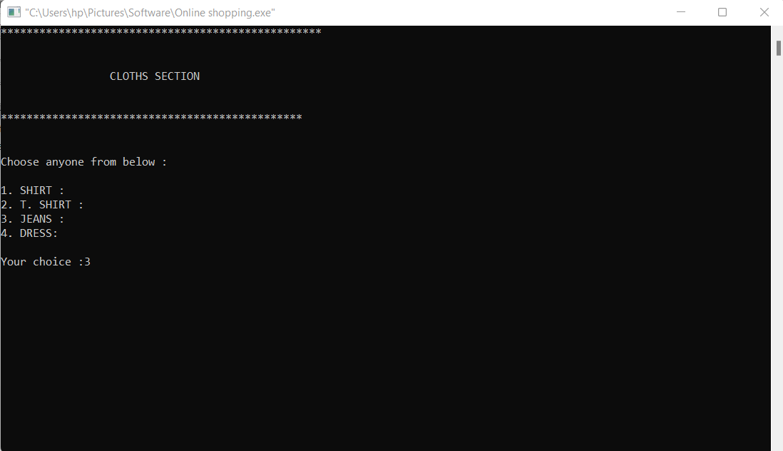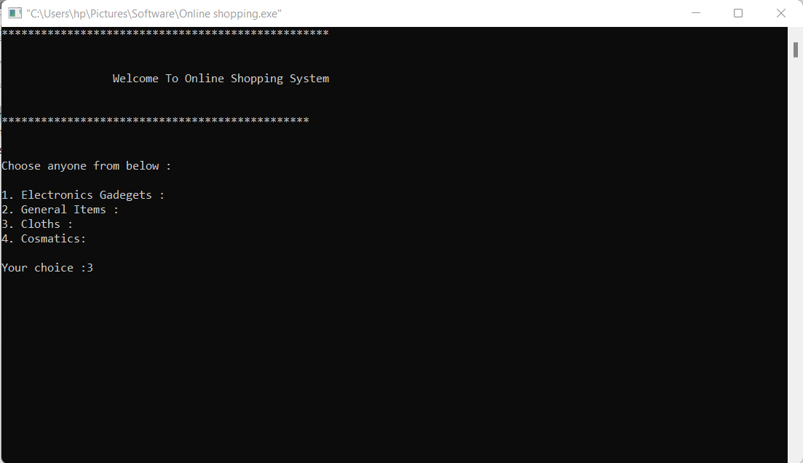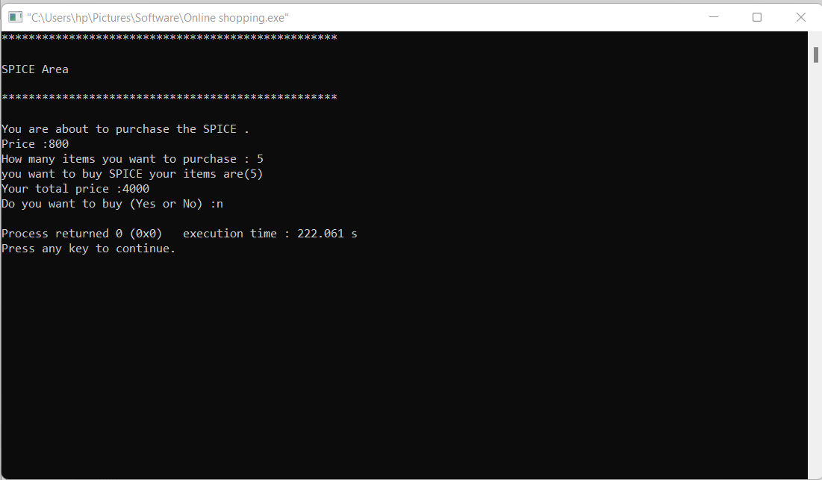

29|Page

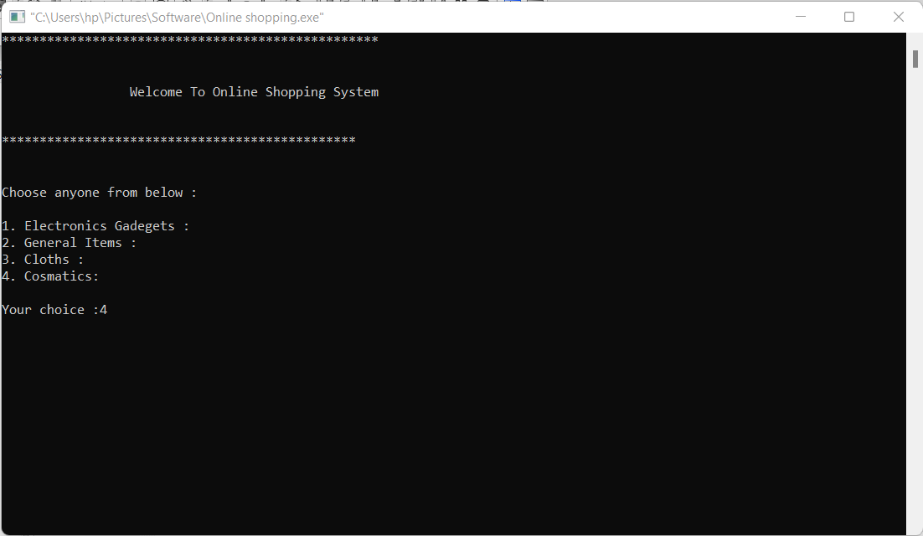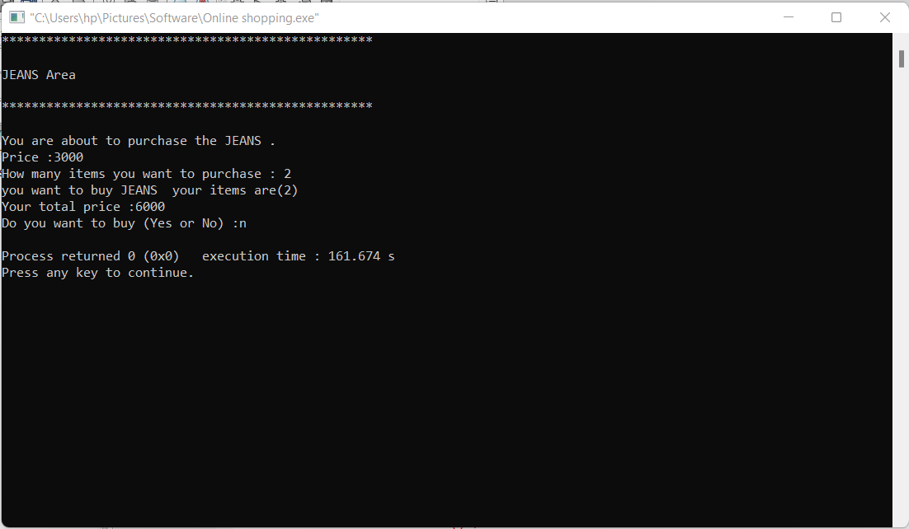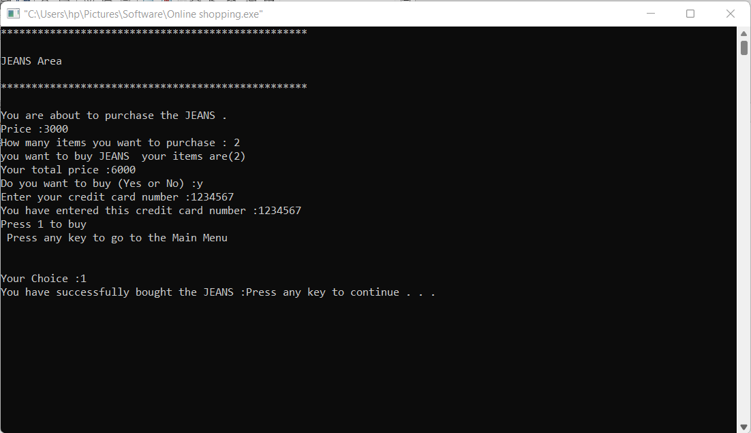

30|Page

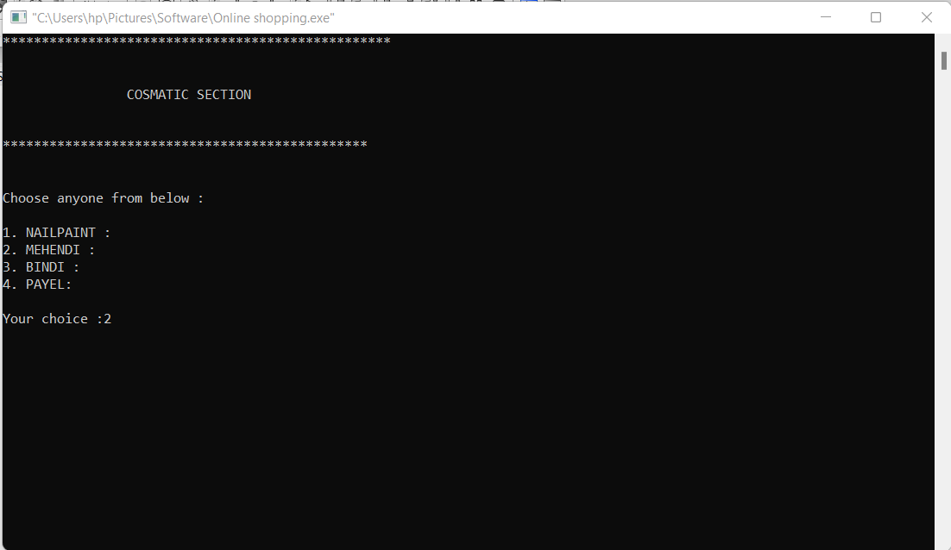

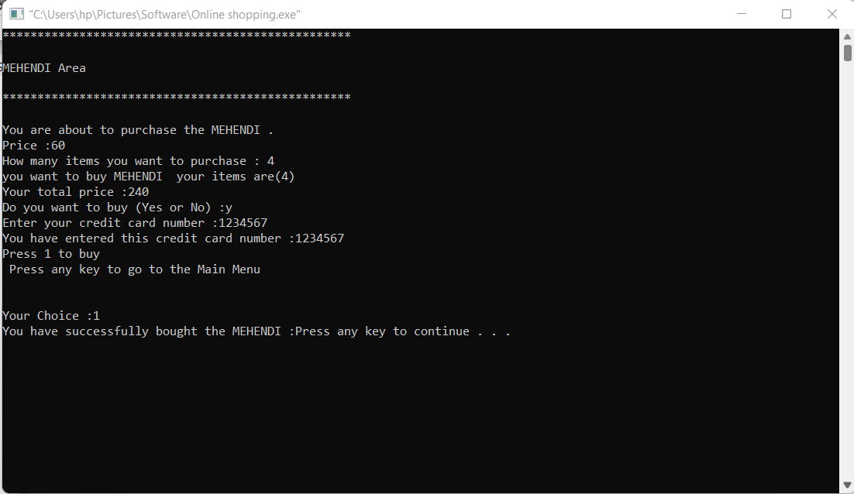

31|Page

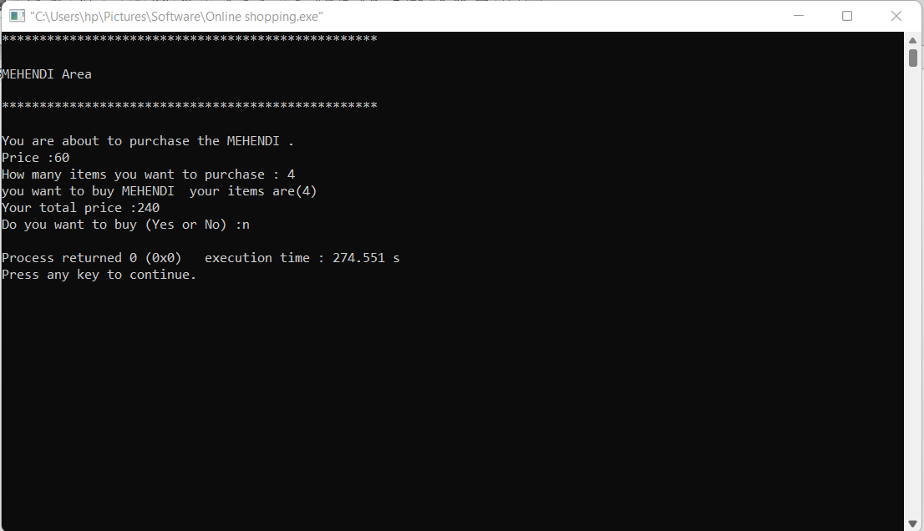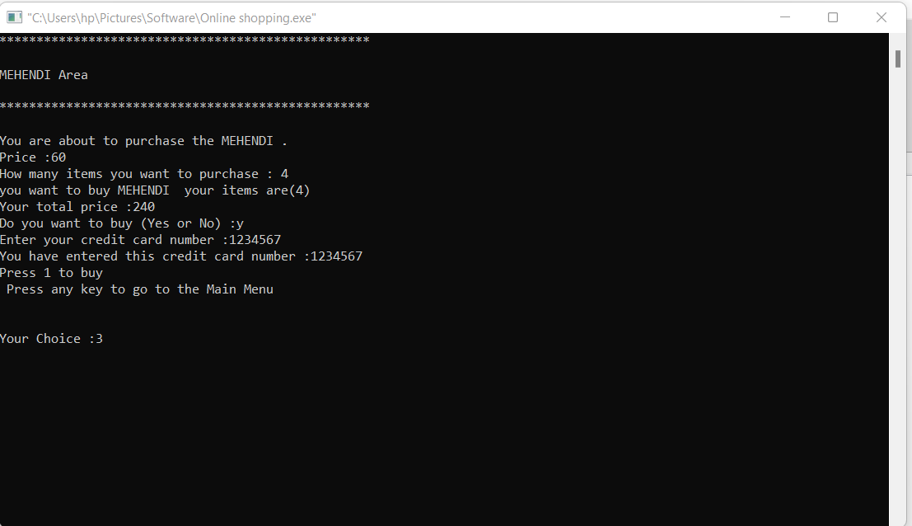

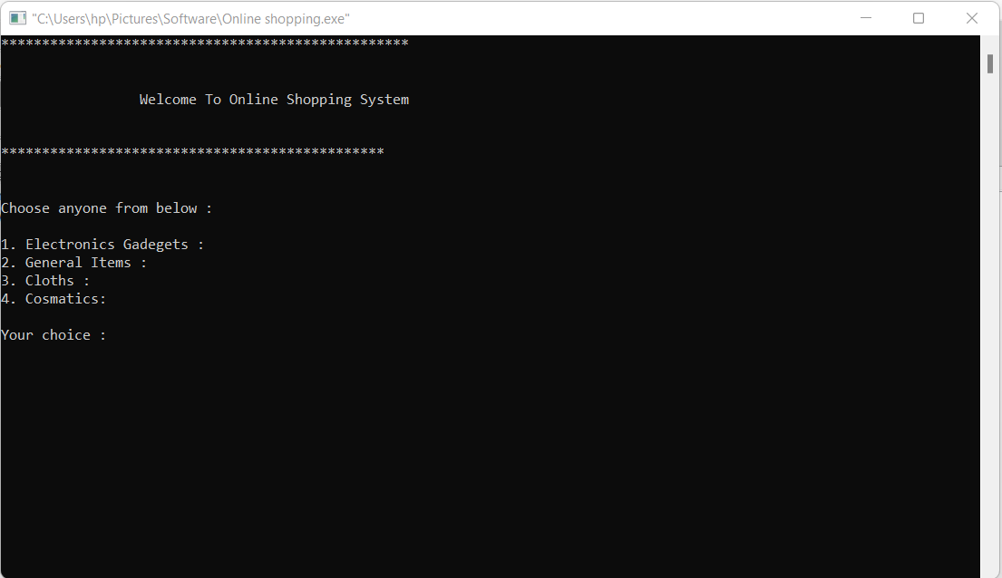

32|Page

CHAPTER - 5

CONCLUTION

After having detail study on online shopping, I can see a great change in the behavior of people in many manners like their attitude, buying pattern. In earlier times people use to do manual shopping but now as time changed, people are becoming busy and due to which technology has brought a new revolution i.e. online shopping. As i started doing research, it came to in notice that young age group people i.e. 15-30 uses of prefer online shopping because it is time and energy saving. But middle age group does not prefer much because they have wrong perception that by seeing the product one can get the goods of proper quality. And even some people does not prefer using plastic money i.e. credit cards. But online shopping has a great future to be successful. It is necessary to spread awareness about it’s benefit.

33|Page

5.1 Future Plan Of Project

* Want to Increase facilities of this project.
* Want to develop graphical design.
* Want to publish this software in online.
* Want to remove all the limitation

REFERENCES

# References

[1] donszem. (2020, March 2). *odmworld.com*. Retrieved from odmworld.com Web site: https://www.odmworld.com/blog/brief-history-of-online-shopping/

*[2] MyAdvo*. (2018, september 14). Retrieved from MyAdvo Web site: https://www.myadvo.in/blog/5-most-common-problems-faced-by-consumers-while-shopping-online/

[3] tram, N. (2021, june 3). *magesolution.com*. Retrieved from magesolution.com Web site: https://www.magesolution.com/blog/shopping-online-problems-customers-faced/

34|Page